***Trương Vũ Minh Vân/2280603646***  
BÀI TẬP TUẦN 5:  
link git: <https://github.com/TruongVuMinhVan/LAPTRINH_WEB>

ảnh 1: (Create)

ảnh 2:  
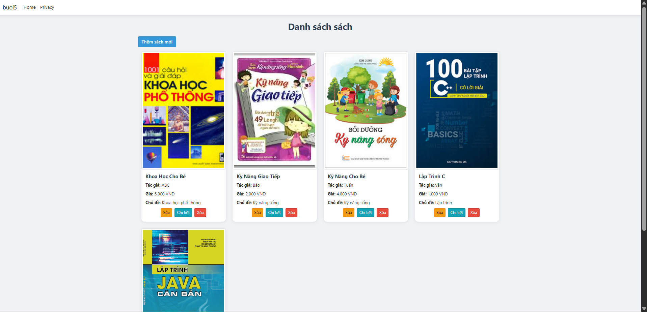

ảnh 3: (Update)

ảnh 4: (Delete)

ảnh 5: (Details)

ảnh 6: (DataBase)

